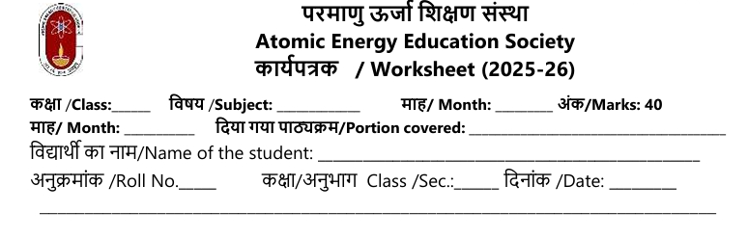Class 7 science Worksheet
Chapter 10 – Life Processes in Plants
Multiple Choice Questions : ( 1 mark each )
1. What are known as the ‘food factories’ of plants?
(a) Roots (b) Stem (c) Leaves (d) Flower
2. Which reagent is used to test the presence of starch in a leaf?
(a) Alcohol (b) Iodine solution (c) Water (d) Chlorophyll
3. What colour implies the presence of starch when iodine is added to a leaf?
(a) Red to yellow (b) Blue to green (c) Blue-black (d) Yellow to red
4. Why do non-green parts of a leaf not produce starch?
(a) They do not get water (b) They do not have chlorophyll (c) They are too small (d) They do not get air
5. Which raw material for photosynthesis is acquired from the air?
(a) Oxygen (b) Carbon dioxide (c) Nitrogen (d) Water
6. The process by which green plants produce their food is called
(a) Respiration (b) Photosynthesis (c) Transpiration (d) Food factory
7. Starch is stored mainly in
(a) Leaves (b) Roots (c) Flowers (d) Fruits
8. The tiny pores on leaf surfaces that allow gas exchange are called
(a) Xylem (b) Phloem (c) Stomata (d) Cuticle
9. Which pigment is vital for capturing sunlight during photosynthesis?
(a) Haemoglobin (b) Chlorophyll (c) Xanthophyll (d) Carotene
10. Energy for most plant life processes is obtained from
(a) Light (b) Chemicals (c) Soil (d) Air
Assertion–Reason Questions (1 mark each)
(a) Both A and R are true and R is the correct explanation of A
(b) Both A and R are true but R is not the correct explanation of A
(c) A is true but R is false
(d) A is false but R is true
11. Assertion (A): Minerals and water from soil are carried by roots to leaves.
Reason (R): Carbon dioxide from the air enters leaves through stomata.
12. Assertion (A): Photosynthesis can occur only in green parts of plants.
Reason (R): Chlorophyll is essential for photosynthesis.
13. Assertion (A): Respiration occurs in all parts of the plant.
Reason (R): Only leaves possess the necessary structures for respiration.
14. Assertion (A): Starch is the storage form of food in plants.
Reason (R): Plants store food in their flowers.
Case Based Questions ( 4 mark)
Read the passage and answer:
Plants require sunlight, water, carbon dioxide, and chlorophyll for food production. The process of photosynthesis mainly occurs in the leaves, and the produced food is stored as starch.
15. What do plants need for photosynthesis?
(a) Sunlight, water, carbon dioxide, chlorophyll
(b) Sunlight and oxygen
(c) Water and minerals
(d) Oxygen and nitrogen
16. Photosynthesis takes place mainly in
(a) Flowers (b) Stems (c) Roots (d) Leaves
17. The food prepared in leaves is transported to other parts by
(a) Xylem (b) Phloem (c) Stomata (d) Guard cells
18. The process by which plants lose water through leaves is
(a) Respiration (b) Transpiration (c) Absorption (d) Photosynthesis
Short answer type Questions ( 2 mark )
19. Define photosynthesis and state its significance for plants.
20. What is the function of stomata in leaves?
21. Why do plants need minerals and water? Mention one main source for each.
22. Differentiate between xylem and phloem in terms of function.
23. What is respiration in plants and why is it essential?Long answer type Questions : ( 3 mark)
24. Describe how water and minerals are transported in plants.
25. Explain the role of chlorophyll in photosynthesis.
26. Write a short note on how plants store food.
27. Describe any two life processes in plants with suitable examples.

